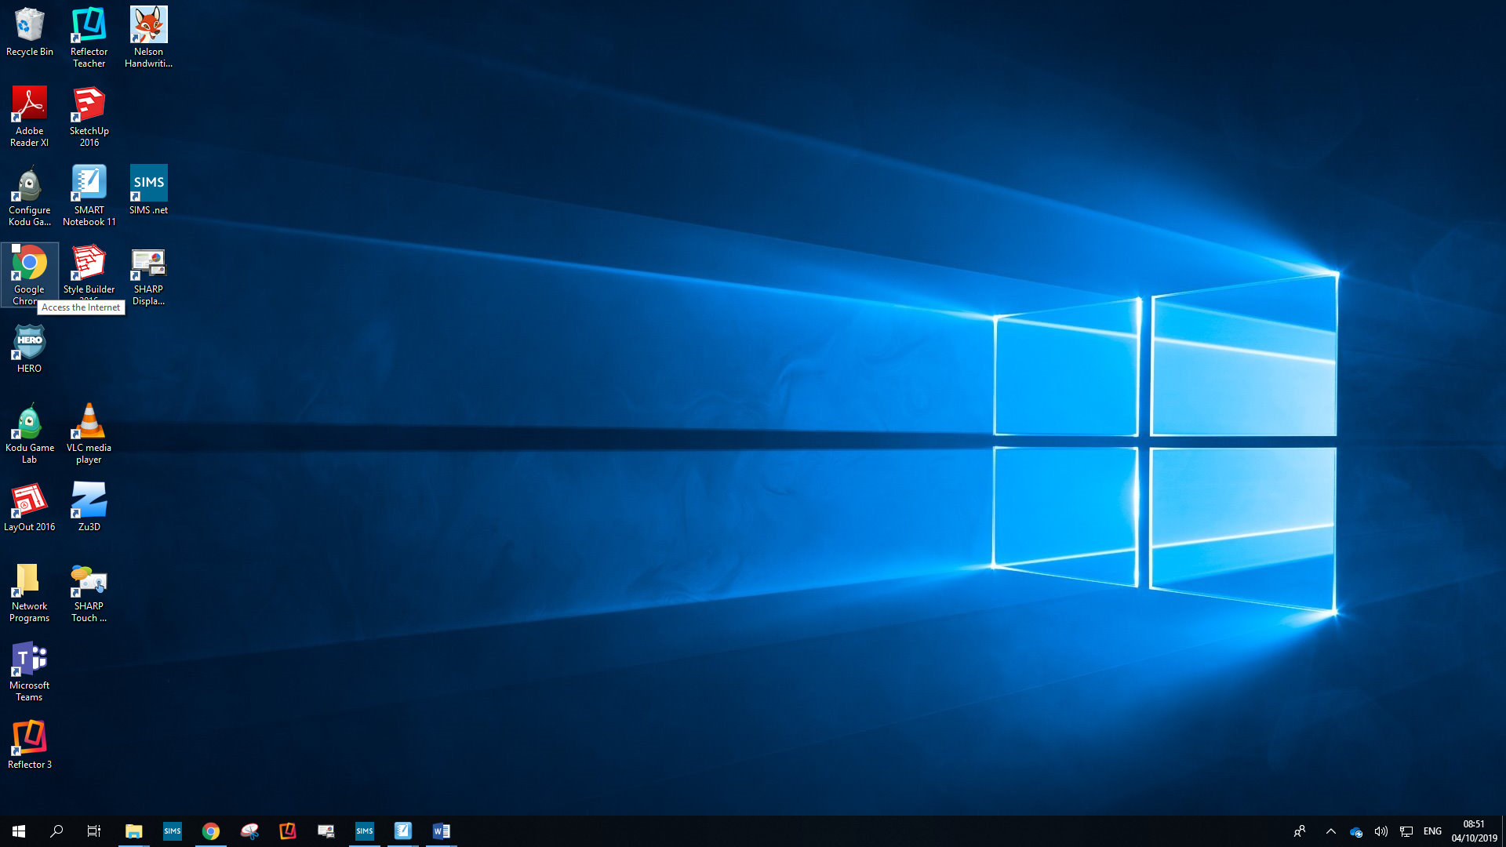
Open up your internet browser (Google Chrome is recommended).

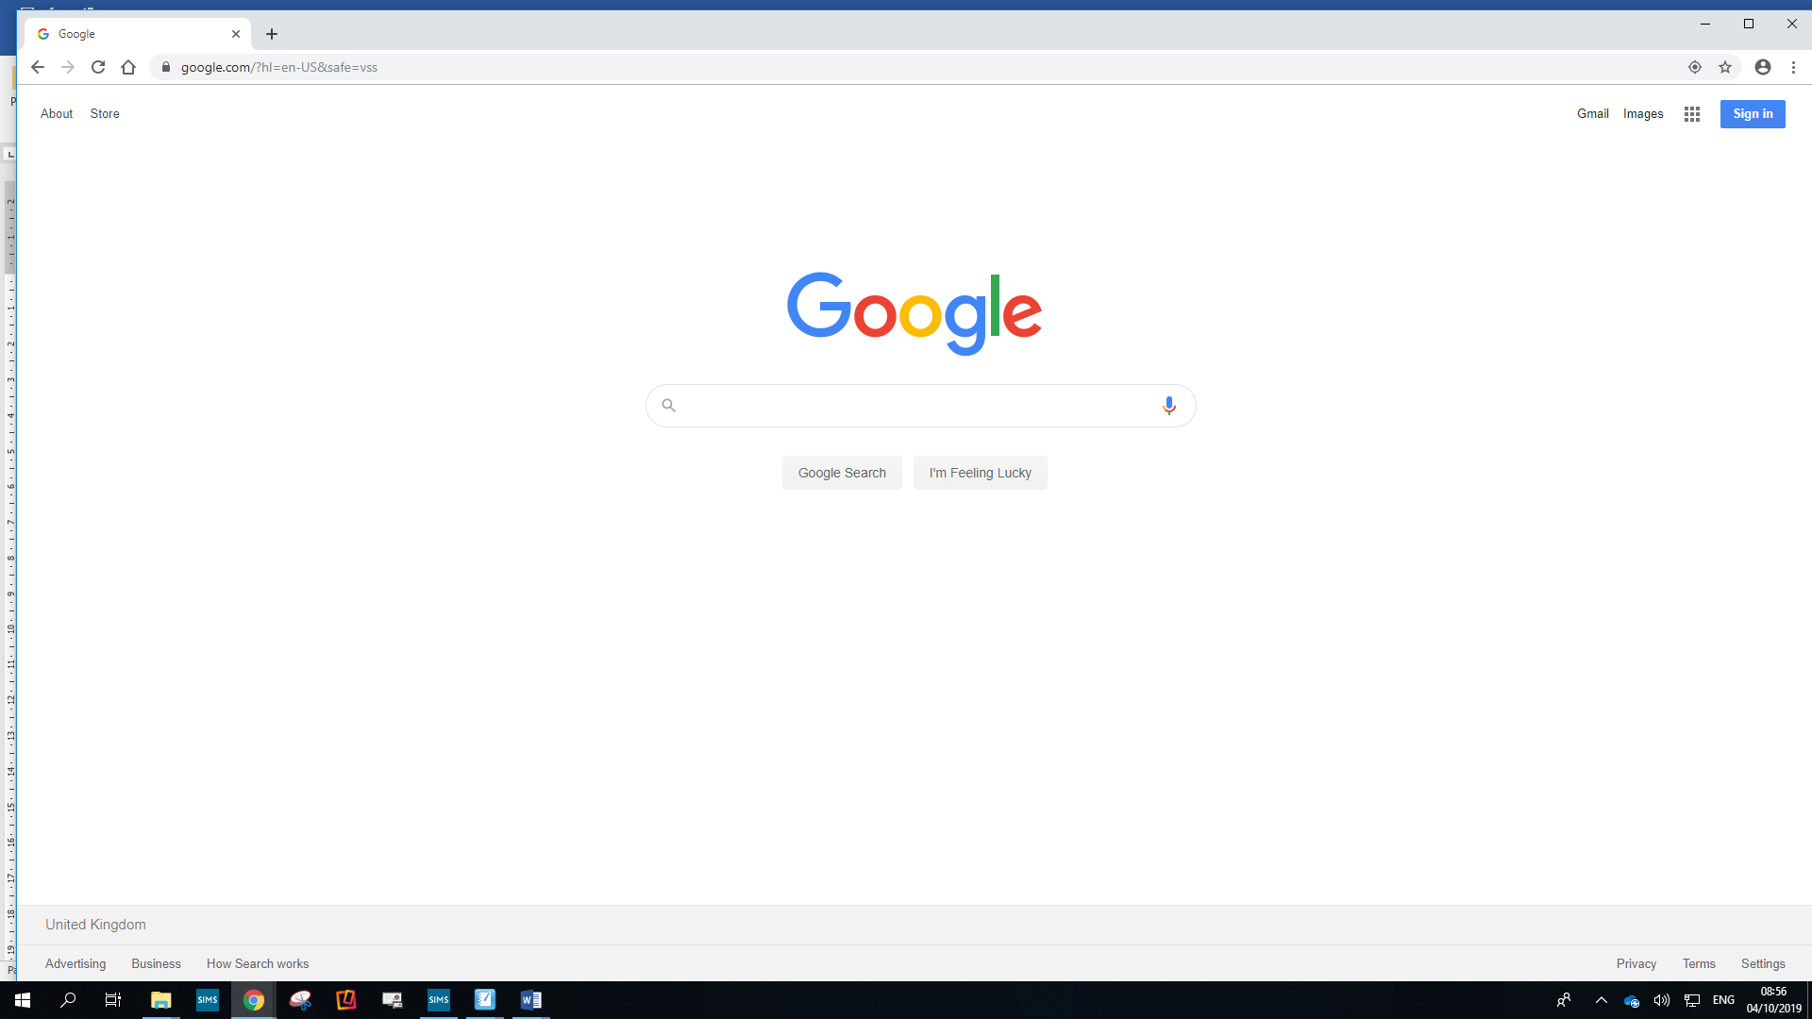
On google.com. Click ‘Sign In’ in the top right corner.
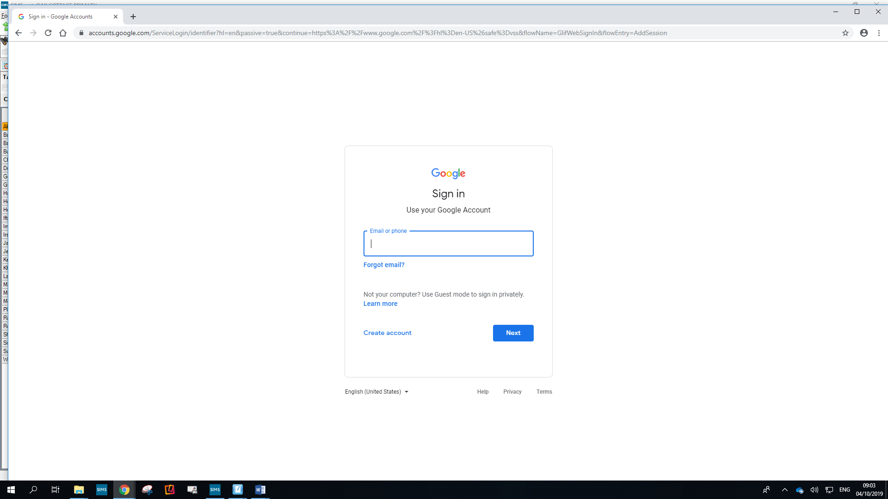

Sign in using your school email address
The first part is 42 followed by your initial and surname.
e.g. 42achild@oak-cottage.solihull.sch.uk

The password should be your usual password.

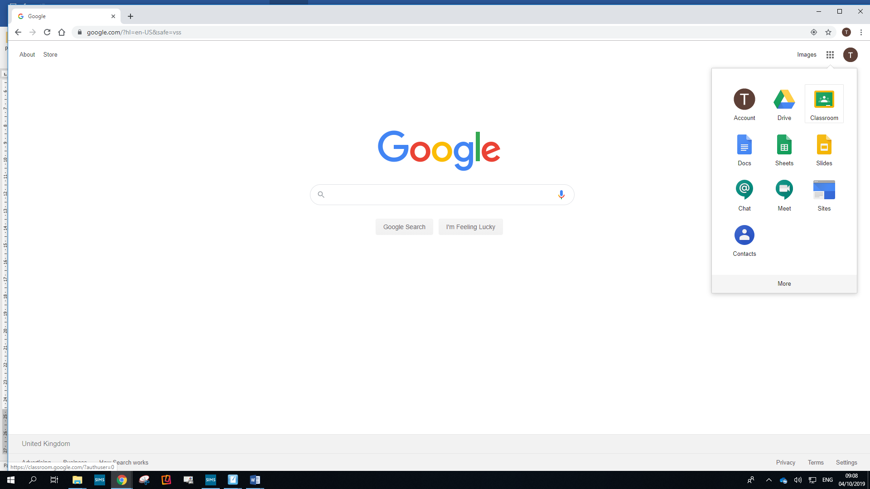
Click on the tile in the corner and then select ‘Classroom’.

